
Netflix is a global entertainment and streaming platform that offers movies, TV shows, documentaries, and other original content across many countries. Analyzing Netflix's content catalog can help uncover trends in content production, audience-oriented genres, international expansion, and the balance between movies and TV shows.

The dataset includes fields that describe each title, such as its name, content type, director, cast, country, date added to Netflix, release year, rating, duration, genres, and description.
Dataset structure
Column | Description
show_id | Unique identifier for each title
type | Movie or TV Show
title | Name of the movie or TV show
director | Director's name
cast | Actors and performers
country | Country or countries associated with the title
date_added | Date the title was added to Netflix
Release_year | Original release year
rating | Content maturity rating
duration | Movie runtime or number of seasons
listed_in | Genres and content categories
description | Summary of the title

Business problems
1. Count the number of Movies vs TV Shows
2. Find the most common rating for movies and TV shows
3. List all movies released in a specific year (e.g., 2021)
4. Find the top 5 countries with the most content on Netflix
5. Identify the longest movie
6. Find content added in the last 6 years
7. Find all the movies/TV shows by director 'Mike Flanagan'!
8. List all TV shows with more than 5 seasons
9. Find the top 10 content items in each genre
10. List all movies that are documentaries
11. Find all content without a director
12. Find in how many movies /TV Shows actor 'Salman Khan' appeared in last 10 years!
13. Find the top 10 actors who have appeared in most number of movies/tv shows produced in India by Netflix
14.Categorize the content based on the presence of the keywords 'kill' and 'violence' in the description field. Label content containing these keywords as 'Bad content' and rest all other content as 'Good content'. Count how many items fall into each category.
15.Find year and the average numbers of content release in India on netflix. return top 5 year with highest avg content release!

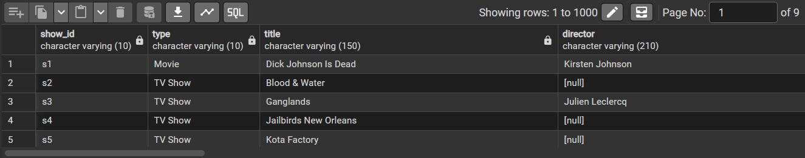

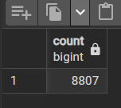

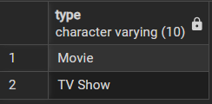

Business Problems and Solutions

